**Demand Forecasting Model Demo**

**Definition of Demand Forecasting**

Demand forecasting is a technique that is used for the estimation of what can be the demand for the upcoming product or services in the future. It is based upon the real-time analysis of demand which was there in the past for that particular product or service in the market present today. Demand forecasting must be done by a scientific approach and facts, events which are related to the forecasting must be considered.

Hence, in simple words, if someone asks what demand forecasting is, we can answer that after fetching information about different aspects of the market and demand which is dependent on the past, an attempt might be made to analyse the future demand.

### Methods of Demand Forecasting

There are two main methods of demand forecasting: 1) Based on Economy and 2) Based on the period.

### 1. Based on Economy

There is a total of three methods of demand forecasting based on the economy:

* **Macro-level Forecasting:** It generally deals with the economic environment which is related to the economy as calculated by the Index of Industrial Production (IIP), national income and general level of employment, etc.
* **Industry-level Forecasting:** Industry-level forecasting usually deals with the demand issued for the industry’s products as a whole. We can consider the example where there is a demand for cement in India, Demand for clothes in India, etc.
* **Firm-level Forecasting:** It is a major type of demand forecasting. Firm-level forecasting means that we need to forecast the demand for a specific firm’s product. We can consider the following examples as Demand for Birla cement, Demand for Raymond clothes, etc.

### 2. Based on the Time

Forecasting based on time may be either short-term forecasting or long-term forecasting.

* **Short-term Forecasting:** It generally covers a short period which depends upon the nature of the industry. It is done generally for six months or can be less than one year. Short-term forecasting is apt for making tactical decisions.
* **Long-term Forecasting:** Long-term forecasts are generally for a longer period. It can be from two to five years or more. It gives data for major strategic decisions of the company. We can consider the example of the expansion of plant capacity or on opening a new unit of business, etc.

### Steps Used in Demand Forecasting

The process of demand forecasting can be divided into five simple steps:

* **Setting an Objective:** The first step involves clearly deciding on the purpose of the analysis. That is, the manufacturers define their goals that are achievable through the analysis and compatible with their needs.
* **Determining the Time Period:** In this step, the manufacturer decides whether the analysis will be carried out for a short or long duration of time. Many forecasts run for a long duration as they offer more and consistent data.
* **Selecting a Demand Forecasting Method:** In the next step, the manufacturer decides along with the analysts which method will give the best results.
* **Collection of Data:** In the penultimate step, the data is collected according to the preconceived attributes for the analysis.
* **Evaluation of Data:** In the last step, the collected data is evaluated to obtain conclusions for the forecast.

**Importance of Demand Forecasting for Ecommerce Businesses:**

**Demand is undoubtedly one of the most important, flexible, and fragile factors that determine the success of a business.**Forecasting your demand helps you a lot with running a business. Here are some of the benefits of demand forecasting.

**Easier To Make Decision: Demand forecasting facilitates important management activities within a company.**Decisions are easier to make and, for instance, performance evaluations are given enough context. Companies know how well the whole business, departments, or employees can cope with future expectations and make decisions accordingly.Deciding how much resources are needed for future demands as well as whether a business is ready for expansion is also made easier**. Companies have enough information to estimate and decide on financial and managerial needs for the future.**

**Helps With Short and Long-Term Planning: Proper demand forecasting helps businesses to easily take care of important strategic plans for the future.**Without knowledge of your demand, long-term business plans like budgeting, financial planning, and capacity planning, among others, are harder to create. These plans are also very much susceptible to inaccuracies and unproductivity. Short and medium-term plans like contract creation and choosing a supplier are also difficult to make. **Demand forecasting gives businesses an idea of what to expect from customers within a period in the future.** It helps managers set [financial goals](https://www.founderjar.com/financial-goals/), create budgets, and allocate the company’s resources efficiently.

### Reduces Cost: Proper knowledge of the expected future demand for goods and services enables businesses to avoid suffering massive losses or opportunity costs. **Costs of production, inventory purchase, and marketing are kept streamlined with estimated forecasts.**With demand forecasting, profit margins are determined and financial resources are not overspent in a way that a profit margin is closed up. Opportunity costs are also avoided. A company knows the opportunities for expansion or the potential for increased demand for goods in the future. Enough inventory is stocked in expectation for this demand and the amount of profit that would have been lost from a stock-out situation is saved.  **The staff required to take care of demand is easily determinable through demand forecasts.**You ensure that you have enough manpower to deal with demand and excess wage is not paid to staff you don't need.

### Pricing Strategy Is Easily Determined: **The demand for a product determines the**[**pricing strategy**](https://www.founderjar.com/pricing-strategies/)**or the price you put on it for profit.** Too much demand for a product without an adequate supply of it causes its price to increase. On the other hand, where the supply of a product becomes more than its demand, its price drops. **Demand forecasting takes this into account and determines the elasticity of demand as it relates to price.** Prices are adequately determined according to future demands of goods. Businesses use demand forecasting to ensure that they do not place prices that are too high for customers and too low for them to generate profits.

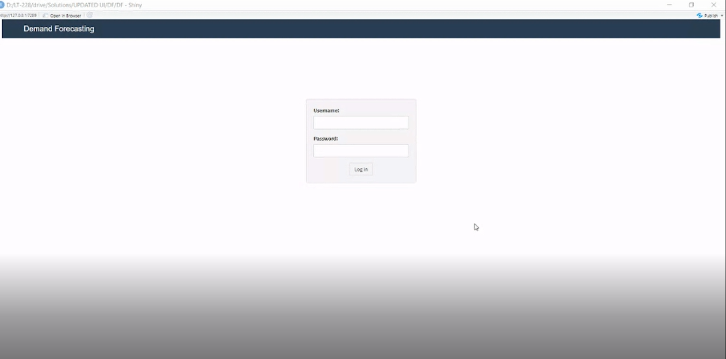

This is the login screen of the Demand Forecasting Application.

* Multitenant cloud application.
* The user registration and application provisioning should happen in advance.
* The above screen is the login screen for the corporate user.
* Two types of user profiles need to be created (admin user, end user).
* Admin screen need to be visualized; admin activities need to be captured.
* User registration form should be created (role should be assigned).
* Customer specific configuration features

**Open Questions:**

* DB finalization for cloud solution
* What is the best user creation or onboarding practise in cloud application?

**Customer specific configuration Features**

* Logo enablement

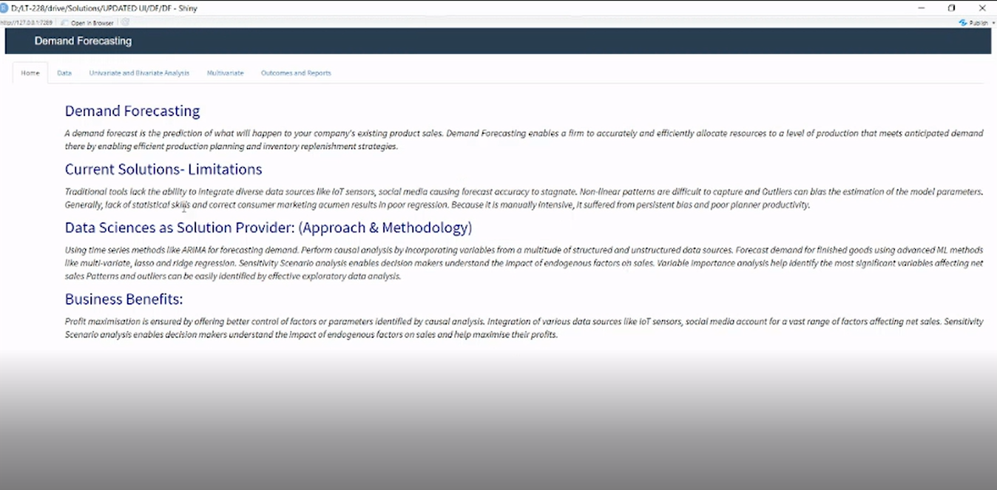

* User Specific Documentation should have ability to edit the document from admin.

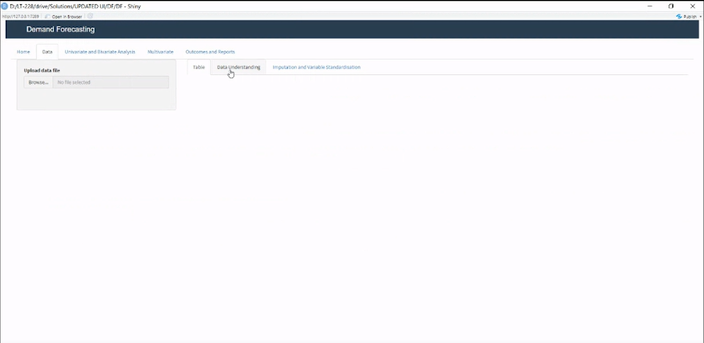

In this page we can upload the dataset that need to be analysed.

* Vision is to pull the data by using APIs from customer ERP system (SAP, Oracle, MS Dynamics).
* File based approach need to be enabled initially.

**Open Question:**

* How to handle the customer specific file parameters?
* Data file need to adopt naming standards based on models
* The file size and the data value can be potentially high for majority of the customers, need to address this requirement.

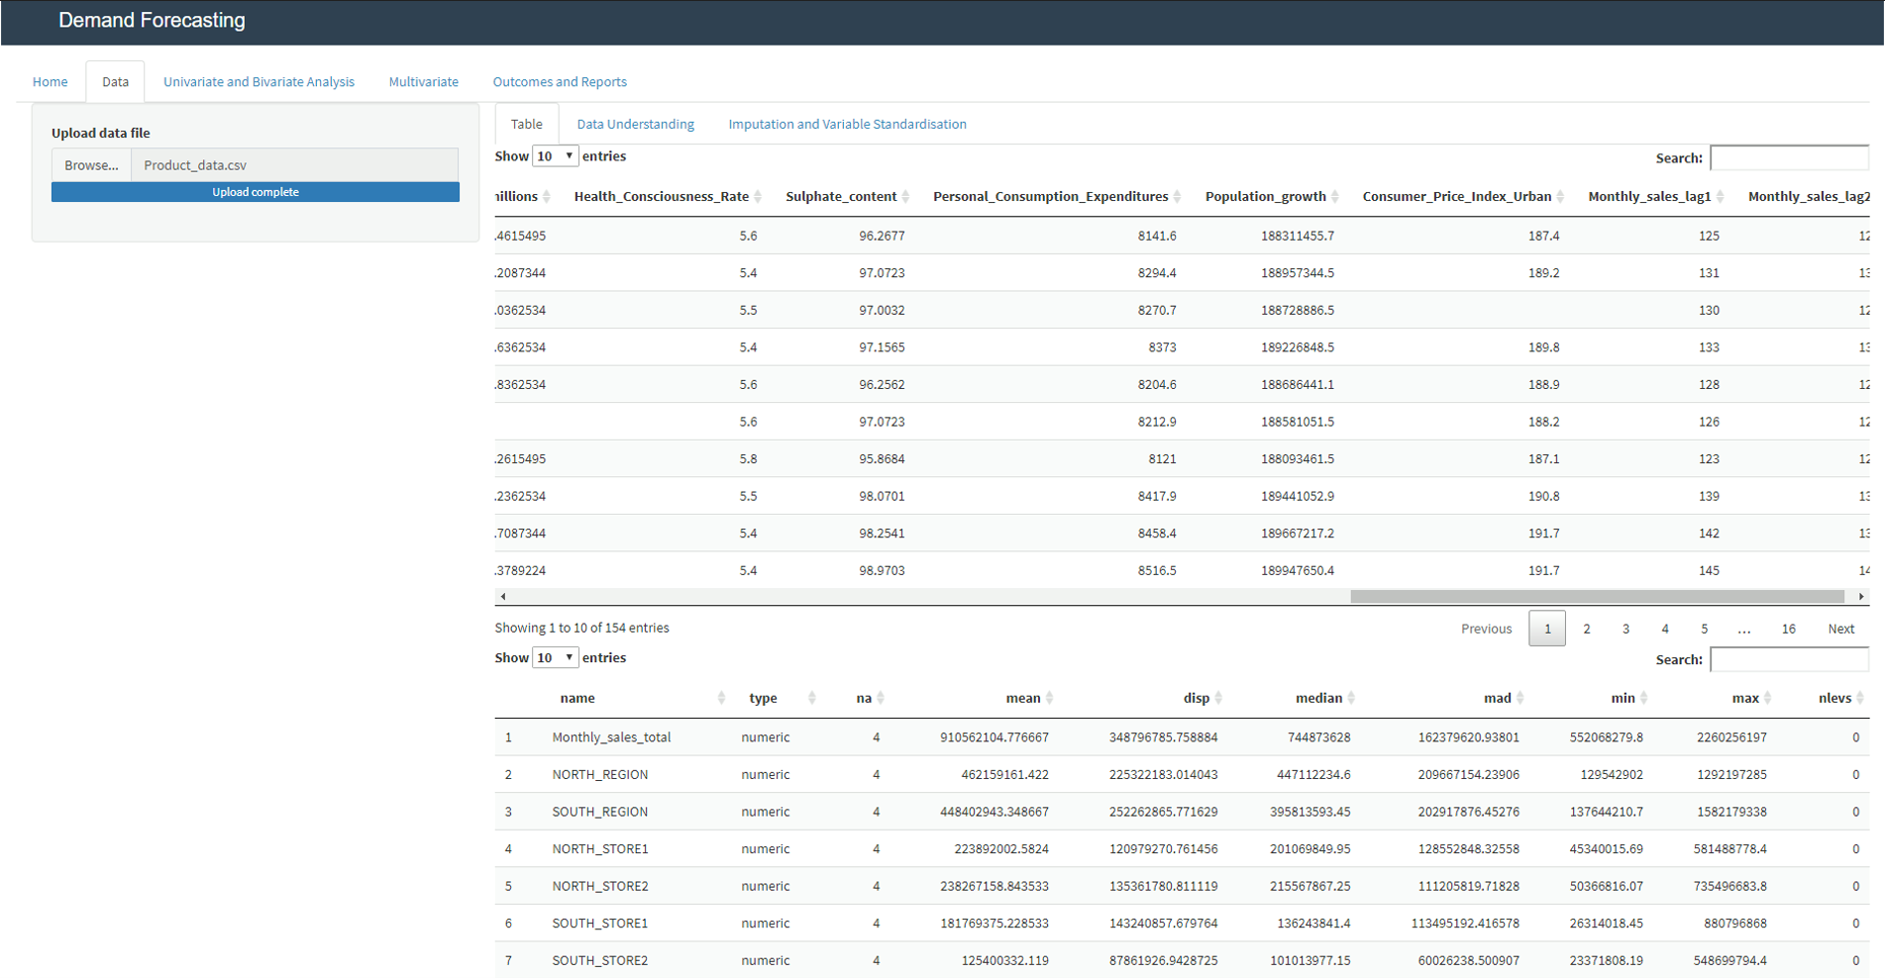

Table 1 displays sample of raw data. Table 2 display the summary of the data.

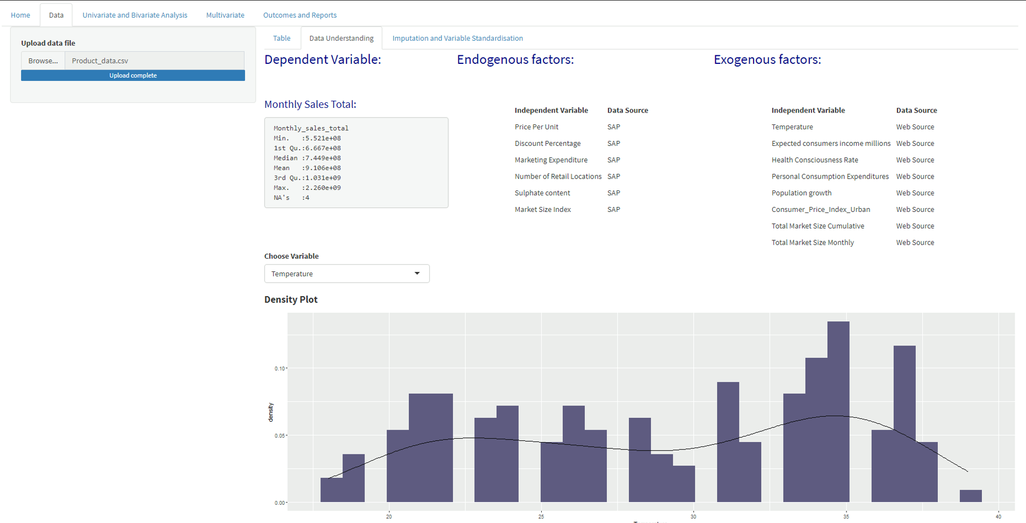

* These variables need to be configured from the backend (from file to file).
* At a given time they should be able to see one chart, by selecting dependent or independent variable.
* All the variables in the data should appear in the list box (For numerical variable distribution, for categorical variables frequency plots).

This is Data Understanding, here we can get know more details about the uploaded dataset like what are the Exogenous factors and Endogenous factors in the dataset, how the values in each column are getting distributed.

Endogenous factors are the factors which influences the business internally.

Exogenous factors are external factors that influences the business.

This model is even showing which variable is dependent and the descriptive statistics of that variable.

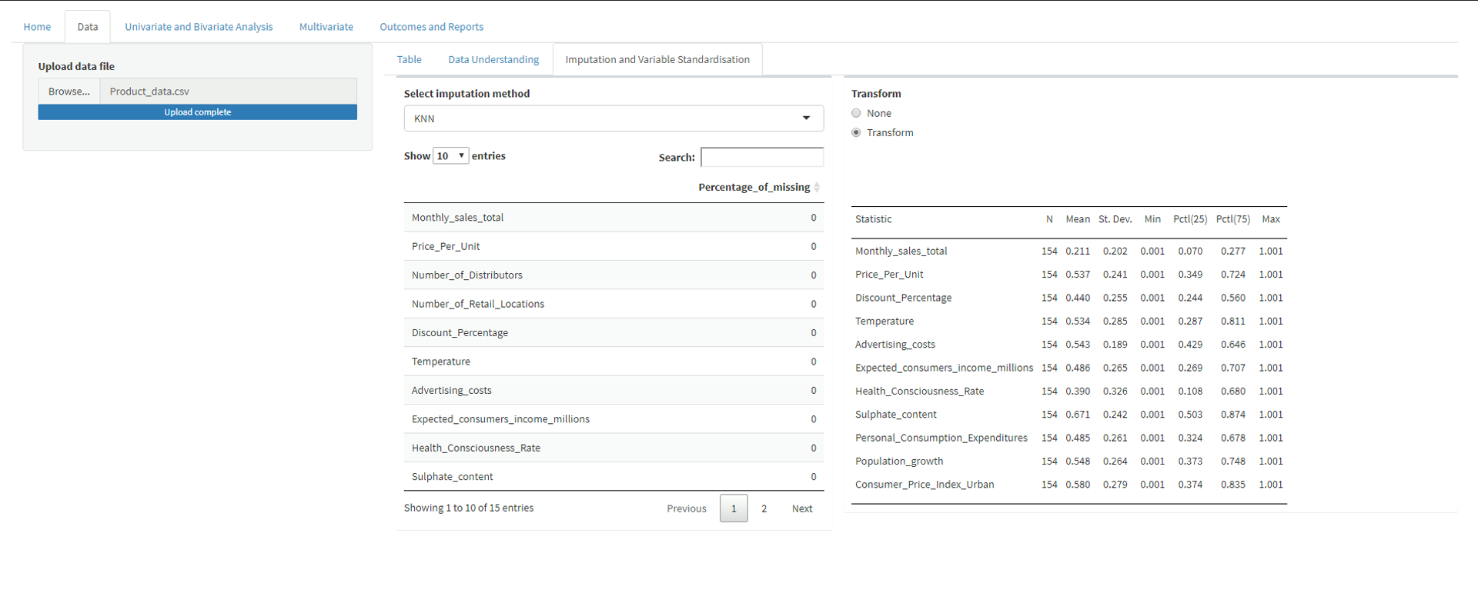

In this screen we can impute and standardize the dataset. Here we can select a method to impute the dataset. Here, we will have pre-defined imputation methods. (The above will be automated and the best imputation technique will be selected).

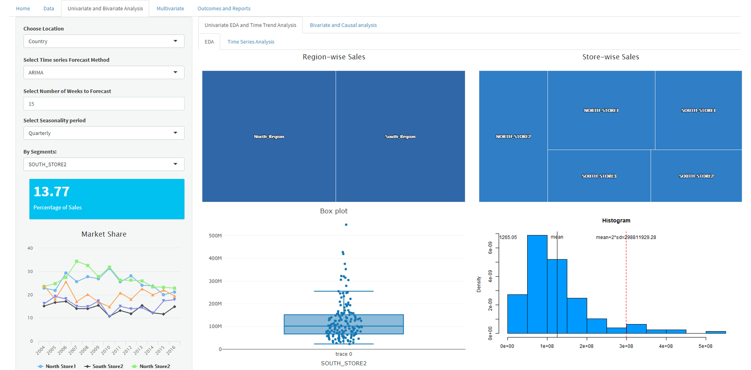

Till now we are done with the understanding and the imputation of the dataset. Now we entered into the Univariate and Bivariate Analysis page.

In this page we can perform EDA and Time Series Analysis

**Exploratory Data Analysis (EDA):**

Studying the patterns in the data improves the forecaster’s chances of successfully modelling data for forecasting applications. Through exploratory data analysis (EDA), a demand forecaster can start the important task of finding factors ([**drivers of demand**](http://bit.ly/2o5SKnV)) that are generally quantitative in nature.

A planned forecasting and modelling effort that does not include provisions for exploratory data analysis often misses the most interesting and important results; but it is only a first step, not the whole story.

Here we can understand the data well in all aspects and we can know the relation between each column of the dataset.

Here, on the left side of the page we can select the parameters like location, Time series forecasting method, Number of weeks to forecast, Seasonality period, Segments to analyse the dataset.

In the left-down corner of the page we can see the market share of each store by selecting it in the Segment.

In the middle of the page, we can see some rectangles representing Region-wise Sales and Store-wise Sales.

In the down we can see a Box Plot and a Histogram Plot showing the distribution of sales of the selected Segment.

In EDA we are looking at sales at different regions and different stores and their performance with time when compared to other regions and stores.

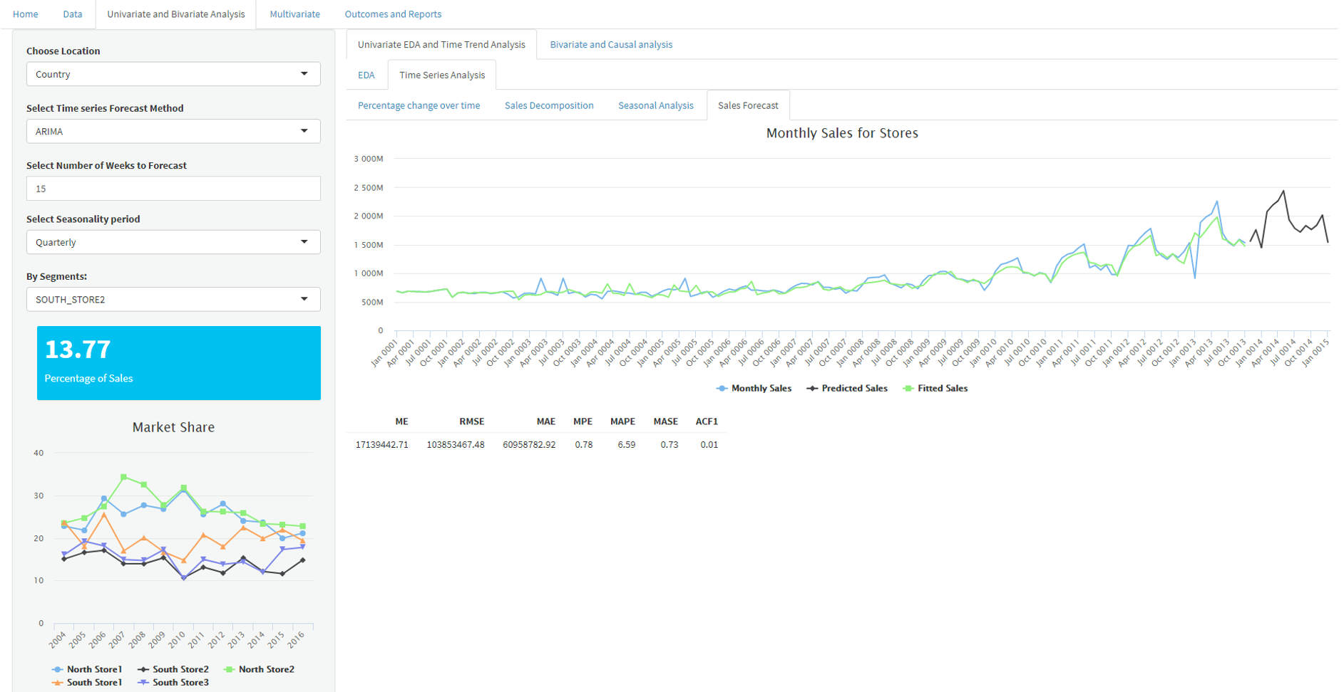

**Time Series Analysis:**

The Series of data points recorded over a specified period of time is called Time-series data**.**Time-series analysis is a technique for analysing time series data and extract meaningful statistical information and characteristics of the data. One of the major objectives of the analysis is to forecast future value. Extrapolation is involved when forecasting with the time series analysis which is extremely complex. But, the forecasted value along with the estimation of uncertainty associated with that can make the result extremely valuable.

In this Demand Forecasting application, it can calculate and plot Percentage Change Over Time, Sales Decomposition, Seasonal Analysis, Sales Forecast.

**Percentage Change Over Time:** In this screen, we can see the percentage change of sales per month. We can see how sales are increasing and decreasing with time. It is based on user selected granularity (Country, region, store etc).

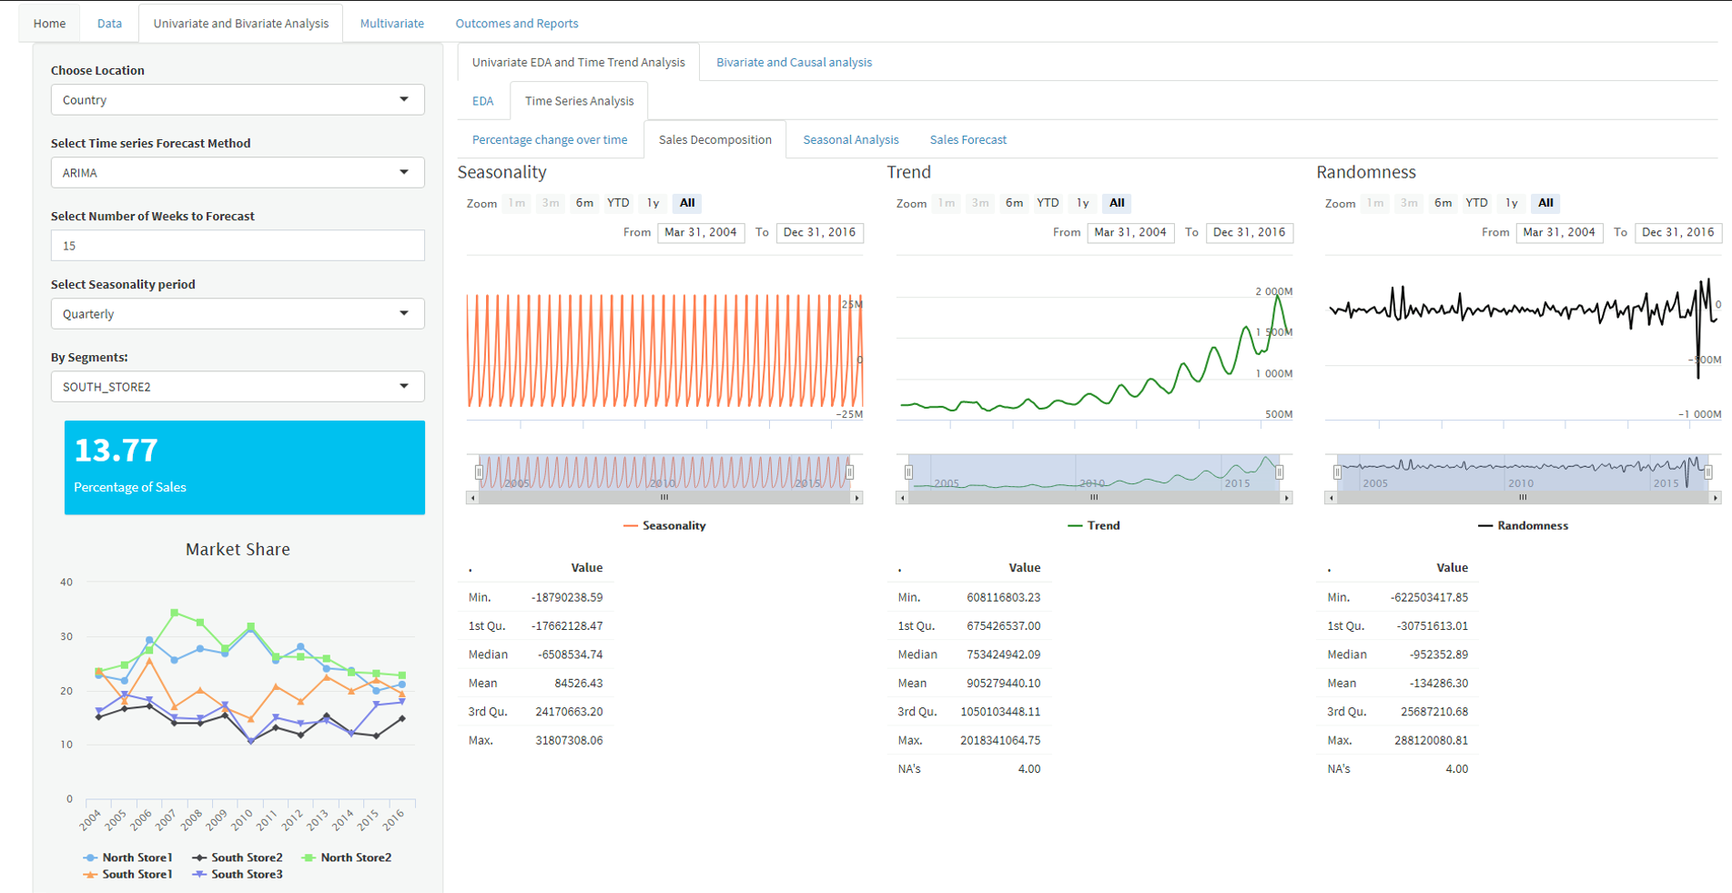

In this screen we can see the decomposition of sales. It decomposed the sales into Seasonality, trend, randomness.

**Decomposition:** Decomposition is a statistical task in which the Time Series data is decomposed into several component or extracting seasonality, trend from a series data. These components are defined as follows:

* Level: The average value in the series.
* Trend: The increasing or decreasing value in the series.
* Seasonality: The repeating short-term cycle in the series.
* Noise: The random variation in the series.

Time series data are combination of these components. All the series have Level and noise. The trend and seasonality components are optional. In time series data, these components are either additively or multiplicatively combined.

**Additive Model:**

Additive Model are the one where the variance of data doesn’t change over different values of the time series. The systematic component is the arithmetic sum of the individual effects of the predictors. Additive model is linear and the trend line here is a straight line and seasonality has same frequency and amplitude (height and width of the cycle respectively).

**Multiplicative Model:**

Multiplicative Model are the one where as the data increases, so does the seasonal pattern or the variance increases. Here the trend and seasonal components are multiplied and then added to the error component. Multiplicative model is non-linear, such as quadratic or exponential and the trend is a curved line and seasonality has an increasing or decreasing frequency and amplitude over time.

Based on the user selected frequency, the seasonality pattern is extracted from the data and the effect of seasonality in sales analysed.

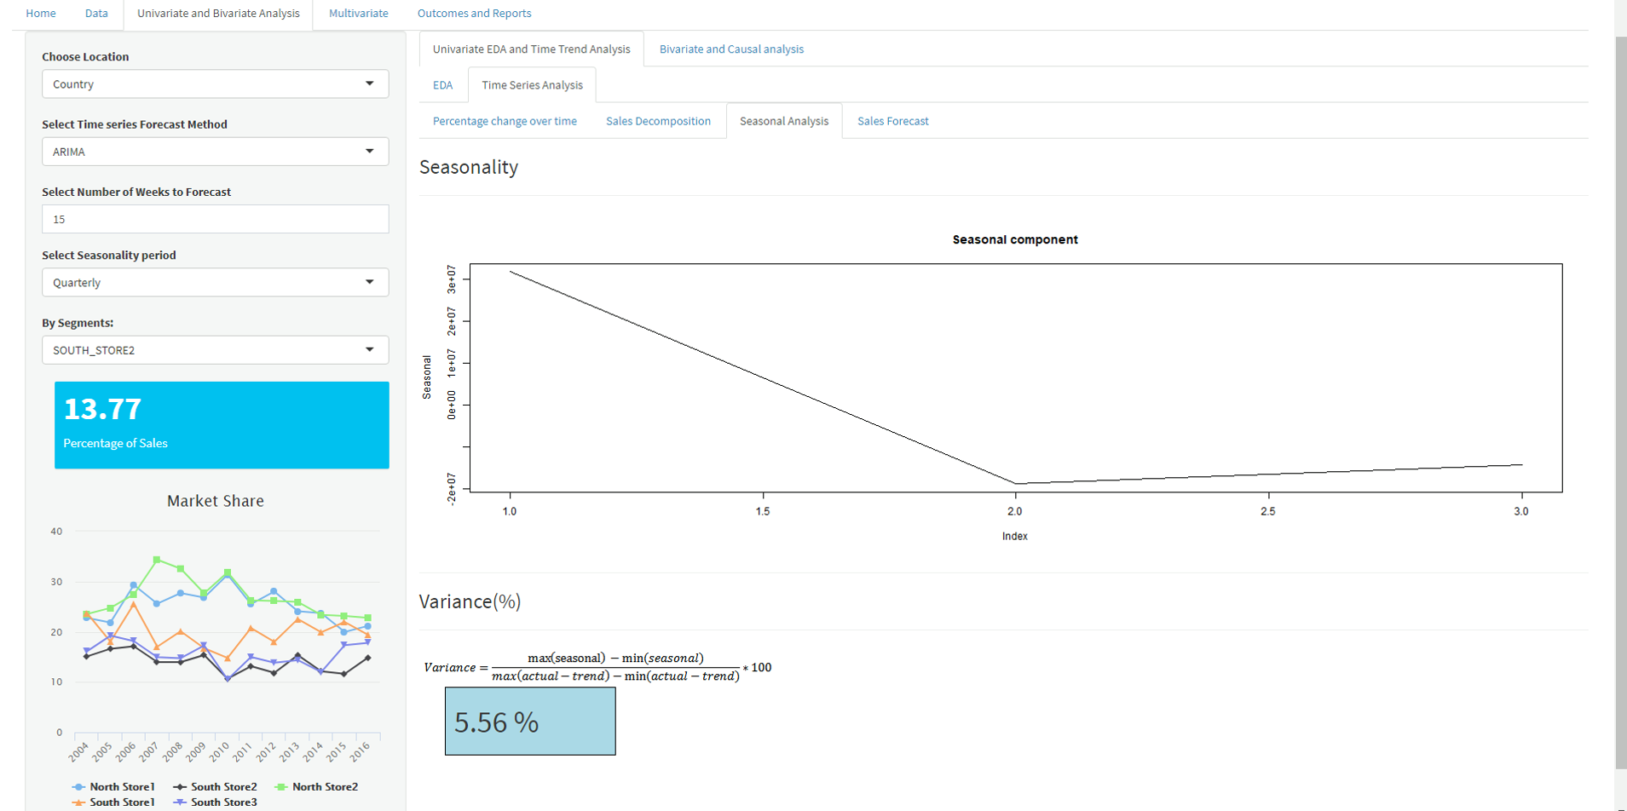

In this screen, we can see the Seasonal Component of the Sales. The plot is showing a particular time period where the sales are reducing gradually.

**Seasonal Analysis:** Seasonality, as its name suggested, refers to the seasonal characteristics of the time series data. It is the predictable pattern that repeats at a certain frequency within one year, such as weekly, monthly, quarterly, etc.

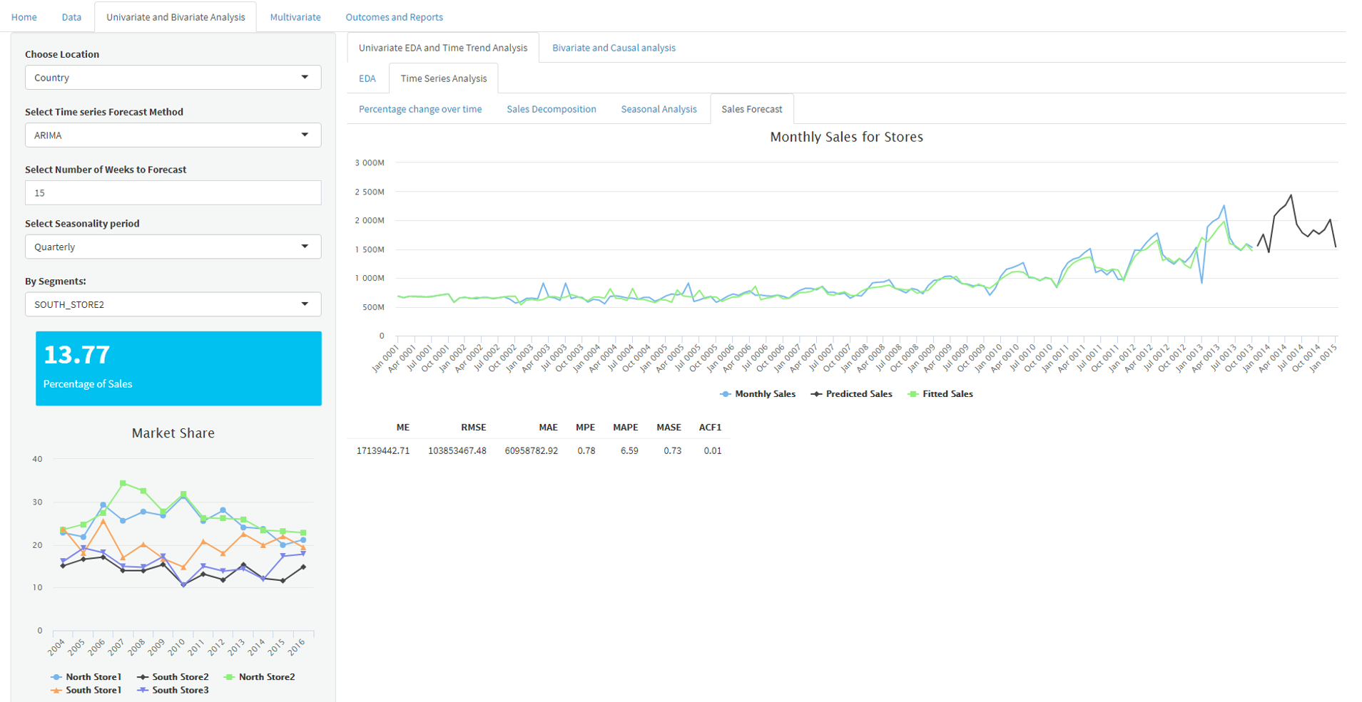

In this screen, we can see the Sales Forecast for Monthly Sales for Stores. In this plot the blue line indicates the Monthly Sales. The green line indicates the Fitted Sales. And the black line that is plotted in a different time line indicating the Future Sales.

The above graph explains about model, model fit, forecast and evaluation through different metrics like, ME, RMSE, MSE, MAE etc

The graph in the left corner indicates the market share of monthly sales in different region with respect to time.

* In the locations box, user should have access to select all the possible locations, regions and country wise.

In the Select Method box, user should be able to select model in terms of ARIMA, SARIMAX, MLR, SLR etc.

In Select Week to forecast box, user should have access to increase or decrease the number of weeks to forecast.

In Select Seasonality Period box, user should have access to select seasonality in terms of Quarterly, Half-yearly and yearly.

In Select Segment box, user should have access to select stores with respect to regions.

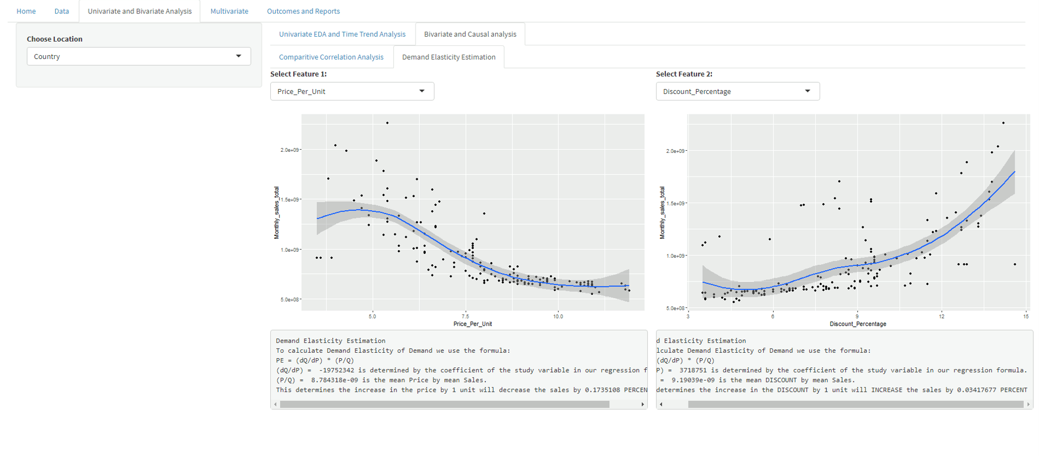

We are done with Univariate. Now let’s see how the application is performing Bivariate Analysis. Here, we can see that the model is performing Demand Elasticity Estimation. In the first plot the model is describing the relationship between the Independent and dependent variable. The model is describing the correlation between an independent variable and a dependent variable. We can select any feature among the dataset to find weather it is correlating positively or negatively with the dependent variable.

* All the Independent variables in the data should appear in the Select Feature Box.

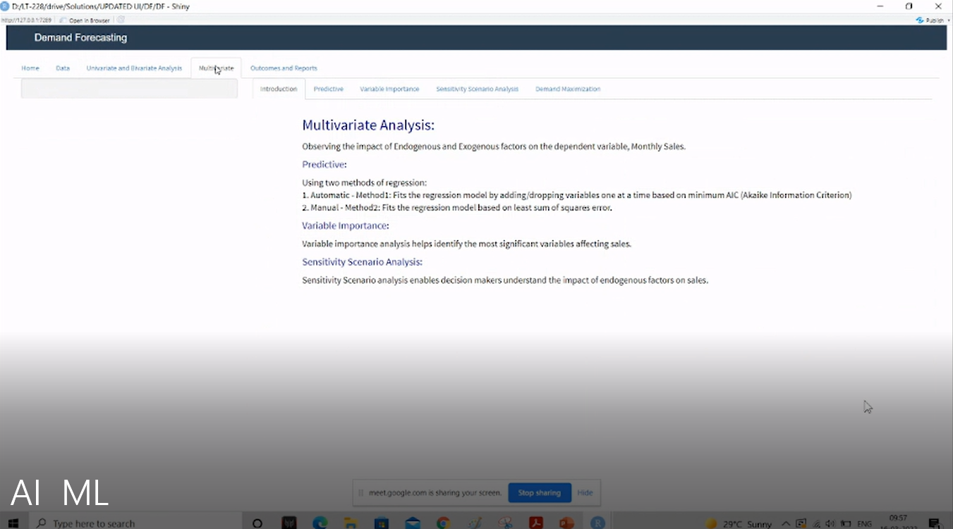

We are done with Univariate and Bivariate Analysis, now let’s see how the model is performing the Multivariate Analysis for the input dataset. Here, we can observe the impact of Endogenous and Exogenous factors on the dependent variable, Monthly Sales.

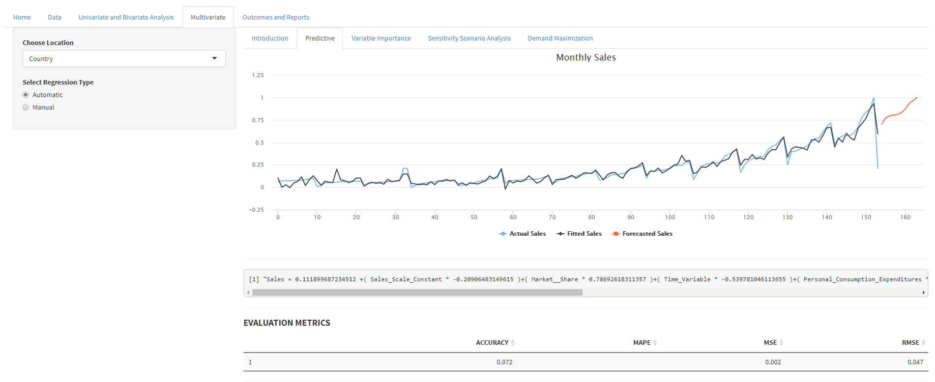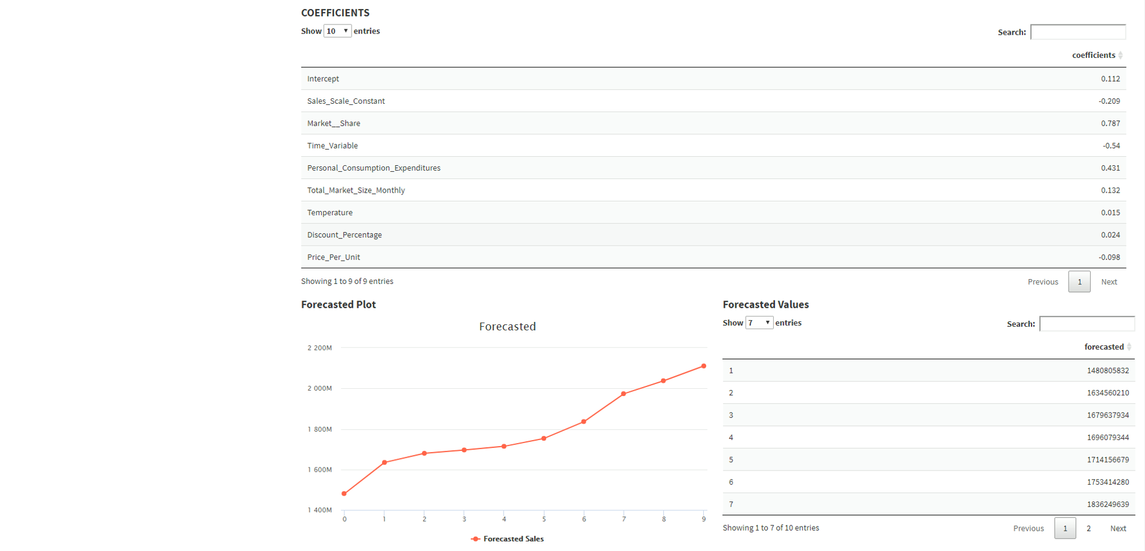

**Predictive Modelling:** Predictive modelling is a commonly used statistical technique to predict future behaviour. Predictive modelling solutions are a form of data-mining technology that works by analysing historical and current data and generating a model to help predict future outcomes. Simply put, predictive analytics uses past trends and applies them to future. For example, if a customer purchases a smart phone from a e-commerce website, he might be interested in it’s accessories immediately. He might be a potential customer for phone battery a few years down the line. Currently, chances of him buying accessory of a competitor smartphone are relatively bleak.

In this screen

In the locations box, user should have access to select all the possible locations, regions and country wise monthly sales, so that the graph explains about model, model fit, forecast and evaluation through different metrics like, ME, RMSE, MSE, MAE etc.

We can see the Forecast Plot for 10 Periods and the forecasted values of the 10 periods.

* User must have multiple options to choose regression automatically or manually.

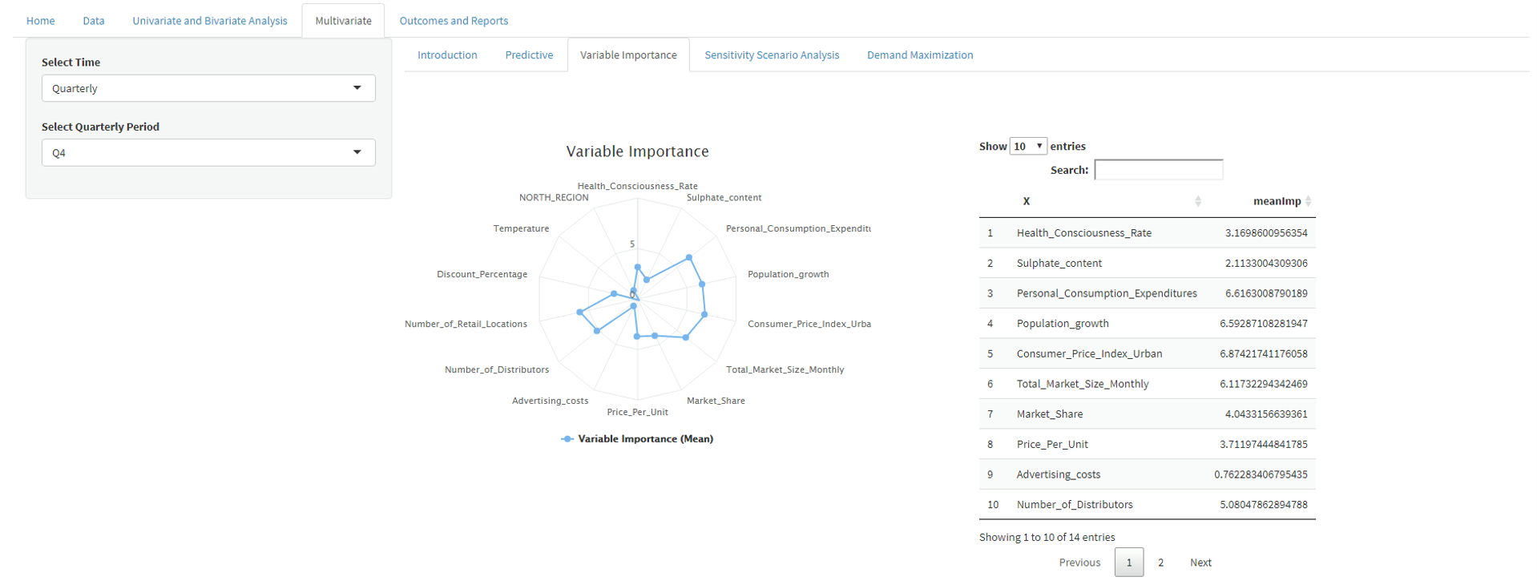

In this screen we can see that the model is performing Variable Importance.

**Variable Importance:** VI represents the statistical significance of each variable in the data with respect to its effect on the generated model. VI is actually each predictor ranking based on the contribution predictors make to the model. This technique helps data scientists weed out certain predictors that are contributing to nothing and that instead add time to processing. Sometimes, the user thinks a variable must contribute to the model, and its VI results are very poor. Feature engineering can be done to improve predictor existence.

* User should have access to select the different parameters like Time and Quarterly Period.

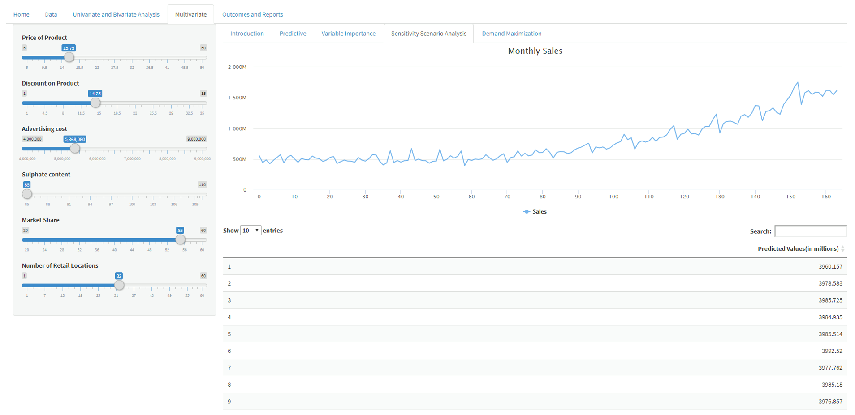

This screen is showing the Sensitivity Scenario Analysis.

**Sensitivity Scenario Analysis:** Scenario and sensitivity analysis helps a financial modeler to understand the major drivers of a project or business. In addition to this, one needs to understand the project or business’s capability of withstanding various scenarios, such as a downturn in the economy. Recent economic activity has shown that these changes can happen suddenly and drastically, which is why scenario analysis is more important than ever.

* It should talk about creating scenarios, different combinations of actionable parameters and analyse their effect on sales for next n periods.

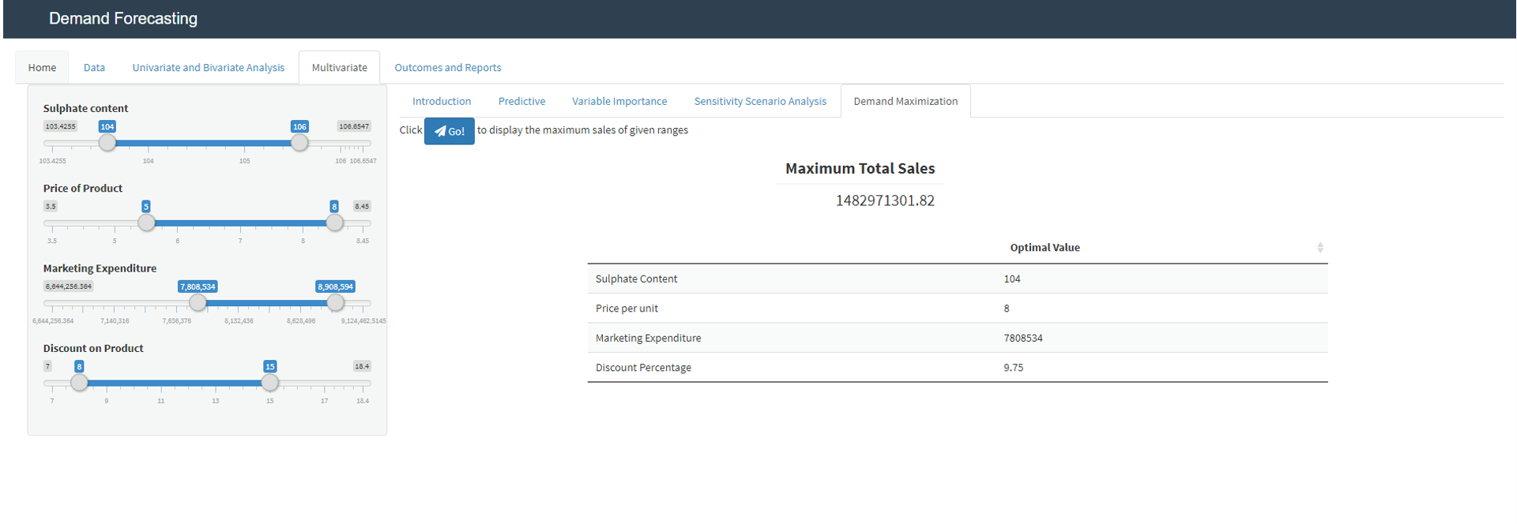

In this screen we can see the Demand Maximization.

* It should talk about creating scenarios, different combinations of actionable parameters in order to get the maximum total sales.
* User should have access to choose and manipulate the actionable parameters.